NADAR SARASWATHI COLLEGE OF ENGINEERING AND TECHNOLOGY

DEPARTMENT OF ELECTRICAL AND ELECTRONICS ENGINEERING

E-FANZINE

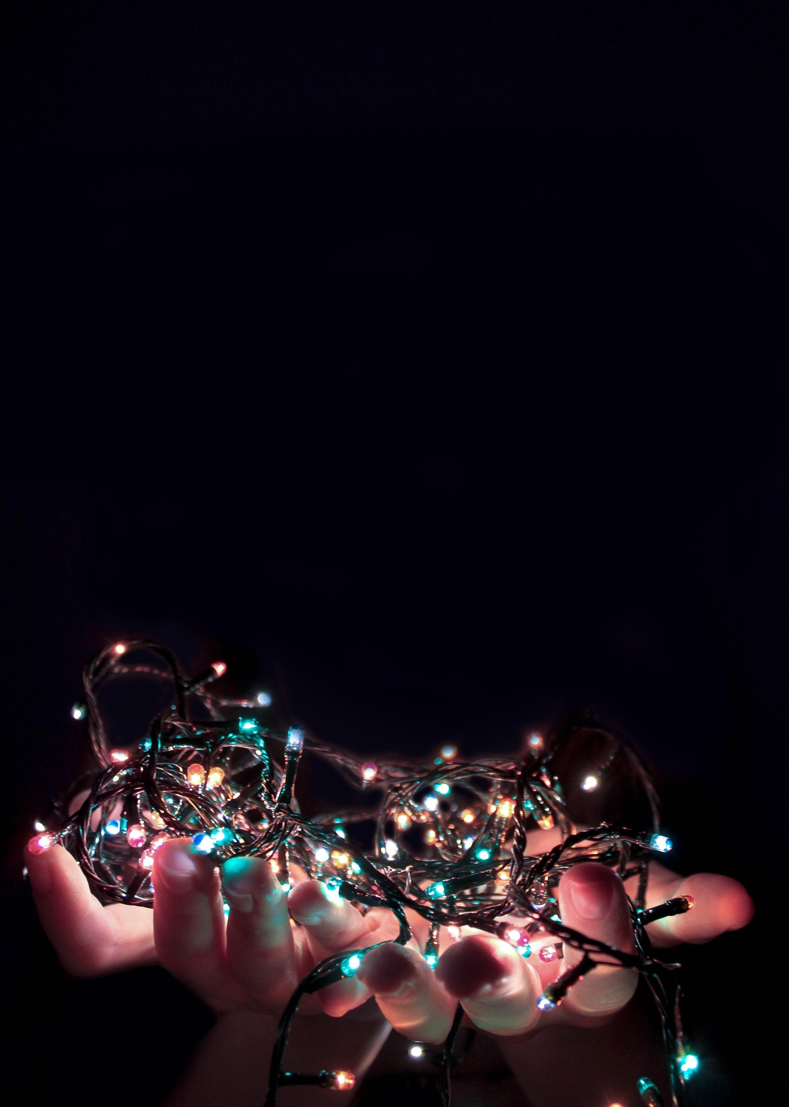VOL.1 ISSUE:8
JUNE 2021

CONTENTS

COLLEGE VISION MISSION
DEPARTMENT VISION MISSION
STAFF ACTIVITY

EDITORIAL BOARD

VOL.NO:1 ISSUE 8 /JUNE 2021

VISION OF NSCET
Place for Technology Revolution

MISSION OF NSCET
Promote and undertake all-inclusive developments. (Vision)
Develop high-quality technical education with academic excellence and innovative research with ethics. (TLP)
Create an atmosphere where teacher enjoys facilitation and learners (students) enjoy learning through foster innovation. (PEO & PSO)
Collaborate with industry and academic to meet the changing needs of society. (PO Attainment)

VISION
Emerge as a valuable global resource for power sector and consumer electronics
MISSION
- Establish the cognitive and effective domains of students through appropriate teaching-learning process and industry-institute interactions.
- Execute projects with integrity and ethics keeping pace with the latest trends in power electronics industry.
- Develop energy technology part to handle various sustainability challenges of the society.
- Upgrade the knowledge and skills of faculty through quality improvement programs.

From the HOD desk

Good day, everybody.

Greetings!!! From The department of Electrical and Electronics Engineering of NSCET. The department of EEE is one of the oldest engineering departments which Enlightens any other engineering discipline. Can you Hink of a minute without ELECTRICAL POWER? NO, We can’t. The cross-country power transmission lines, household lights, and motors to name the very few are the best examples illustrating this. We, He electrical engineers have created a great infrastructure in which the world runs on top of it. We will also create the future. WIRELESS POWER TRANSFER, SOLAR POWER, ELECTRICAL
VEHICLES, to name a few. The future is OURs.
We dedicate E-FANZINE, to the students’ fraternity of the EEE department of our institution. Students can actively do a variety of activities which takes them towards becoming an industry leader. All of these activities can be documented in this newsletter. This newsletter is monthly where any student and faculty can contribute to it. I wish all the students and faculty make full use of it and a grand success.

M.Arivalagan HOD/EEE.

VOL.NO:1 ISSUE 8 / JUNE 2021

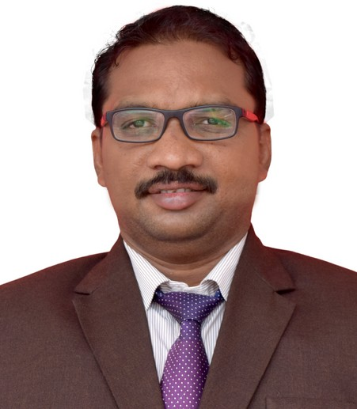
Mr. ARIVALAGAM
HOD/EEE

He has participated in the one day online short-term webinar program on Energy audit and management, organized by Department of Electrical and Electronics Engineering, Alagappa Chettiar Government college of engineering and Technology, Karaikudi on 9th June 2021.
He actively Participated in the webinar on “Android design basics and server connection using volley” organized by Department of Computer Engineering, Nadar Saraswathi college of engineering and Technology, Theni with Industry Institute Partnership Cell (IIPC) on 4th June 2021.

He has participated in the one day online short-term webinar program on Power system network and latest development, organized by Department of Electrical and Electronics Engineering, Nadar Saraswathi college of engineering and Technology, Theni with Industry Institute Partnership Cell (IIPC) on 12th June 2021.

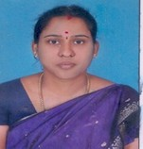
MS. K. MALAR
AP/EEE
He actively Participated in the webinar on “Android design basics and server connection using volley” organized by Department of Computer Engineering, Nadar Saraswathi college of engineering and Technology, Theni with Industry Institute Partnership Cell (IIPC) on 4th June 2021.

He has participated in the one day online short-term webinar program on Energy audit and management, organized by Department of Electrical and Electronics Engineering, Alagappa Chettiar Government college of engineering and Technology, Karaikudi on 9th June 2021.

He has participated in the one day online short-term webinar program on Power system network and latest development, organized by Department of Electrical and Electronics Engineering, Nadar Saraswathi college of engineering and Technology, Theni with Industry Institute Partnership Cell (IIPC) on 12th June 2021.

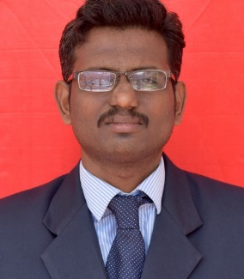

Mr. K. GANESH
AP/EEE
He actively Participated in the webinar on “Android design basics and server connection using volley” organized by Department of Computer Engineering, Nadar Saraswathi college of engineering and Technology, Theni with Industry Institute Partnership Cell (IIPC) on 4th June 2021.

He has participated in the one day online short-term webinar program on Energy audit and management, organized by Department of Electrical and Electronics Engineering, Alagappa Chettiar Government college of engineering and Technology, Karaikudi on 9th June 2021.

He has participated in the one day online short-term webinar program on Power system network and latest development, organized by Department of Electrical and Electronics Engineering, Nadar Saraswathi college of engineering and Technology, Theni with Industry Institute Partnership Cell (IIPC) on 12th June 2021.

.

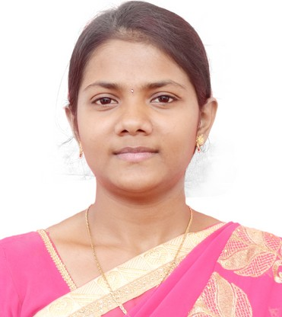

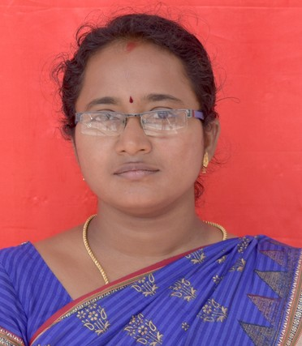

MS. B.SHANHINI

AP/EEE

WEBINAR:
She actively Participated in the webinar on “Android design basics and server connection using volley” organized by Department of Computer Engineering, Nadar Saraswathi college of engineering and Technology, Theni with Industry Institute Partnership Cell (IIPC) on 4th June 2021.

She actively Participated in the webinar on “Power system network and latest developments” organized by Department of Electrical and Electronics Engineering, Nadar Saraswathi college of engineering and Technology, Theni with Industry Institute Partnership Cell (IIPC) on 12th June 2021.

MS. M.DIVYABHARATHI

AP/EEE

WEBINAR:
She actively Participated in the webinar on “Android design basics and server connection using volley” organized by Department of Computer Engineering, Nadar Saraswathi college of engineering and Technology, Theni with Industry Institute Partnership Cell (IIPC) on 4th June 2021.

She actively Participated in the webinar on “Power system network and latest developments” organized by Department of Electrical and Electronics Engineering, Nadar Saraswathi college of engineering and Technology, Theni with Industry Institute Partnership Cell (IIPC) on 12th June 2021.

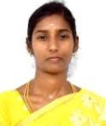

MRS. R.CHITRA

AP/EEE

WEBINAR:
She actively Participated in the webinar on “Android design basics and server connection using volley” organized by Department of Computer Engineering, Nadar Saraswathi college of engineering and Technology, Theni with Industry Institute Partnership Cell (IIPC) on 4th June 2021.

She actively Participated in the webinar on “Power system network and latest developments” organized by Department of Electrical and Electronics Engineering, Nadar Saraswathi college of engineering and Technology, Theni with Industry Institute Partnership Cell (IIPC) on 12th June 2021.

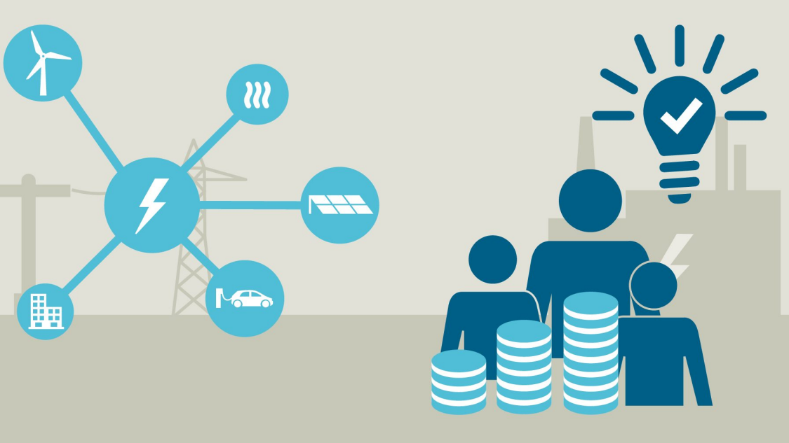

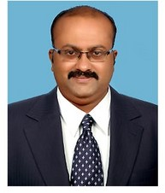

Dr. M. PANDIMAHARAJAN

ASSOSIATE PROFESSOR/EEE

WEBINAR:
He actively Participated in the webinar on “Android design basics and server connection using volley” organized by Department of Computer Engineering, Nadar Saraswathi college of engineering and Technology, Theni with Industry Institute Partnership Cell (IIPC) on 4th June 2021.

He actively Participated in the webinar on “Investor awareness program” organized by Ambition leaning Solutions on 15th June 2021.

He actively Participated in the webinar on “Modelling of System and design of controller using MATLAB” organized by Department of Electrical and Electronics Engineering, DMI college of engineering, Chennai 25th June 2021.

Mr. N. RATHINAVEL SUBRAMANIAN

AP/EEE
He actively Participated in the webinar on “Android design basics and server connection using volley” organized by Department of Computer Engineering, Nadar Saraswathi college of engineering and Technology, Theni with Industry Institute Partnership Cell (IIPC) on 4th June 2021.

He has participated in the one day online short-term webinar program on Energy audit and management, organized by Department of Electrical and Electronics Engineering, Alagappa Chettiar Government college of engineering and Technology, Karaikudi on 9th June 2021.

He has participated in the one day online short-term webinar program on Power system network and latest development, organized by Department of Electrical and Electronics Engineering, Nadar Saraswathi college of engineering and Technology, Theni with Industry Institute Partnership Cell (IIPC) on 12th June 2021.

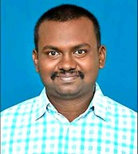

Mr. S. RAHUL SOMNAATH

AP/EEE
He actively Participated in the webinar on “Android design basics and server connection using volley” organized by Department of Computer Engineering, Nadar Saraswathi college of engineering and Technology, Theni with Industry Institute Partnership Cell (IIPC) on 4th June 2021.

He has participated in the one day online short-term webinar program on Energy audit and management, organized by Department of Electrical and Electronics Engineering, Alagappa Chettiar Government college of engineering and Technology, Karaikudi on 9th June 2021.

He has participated in the one day online short-term webinar program on Power system network and latest development, organized by Department of Electrical and Electronics Engineering, Nadar Saraswathi college of engineering and Technology, Theni with Industry Institute Partnership Cell (IIPC) on 12th June 2021.

PLACEMENT ACTIVITIES

Our department students Prathiksha and Samitha Manju Shree placed in the L.G. Balakrishna Pvt. Ltd.,
In June, we have delivered the technical, Aptitude, Current Affairs, and Communication Contents are Shared to the student, and also, we conducted the weekly quiz based on their respective topics.

EDITORIAL BOARD

Editor in Chief
Mr. M. Arivalagan HOD/EEE

Editor
Mr. S. Rahul Somnath AP/EEE

Design team
Ms. M. DivyaBharathi AP/EEE
Student members
- Aisswarya Laksmi.M
- Abinayadevi
- Nisha. V
- Senthamilan.S
- Shanmuga Pandian.M
- Sutharsan.T
- Sundharamagalingam.M

VOL.NO:1 ISSUE 8 / JUNE 2021

